Plain Diction

🧾 What is Plain Diction
# Source: AI Source: Provided by: [Data Path: Persons Table -> ID Column: 1, Name_En Column: Motasem Essam] -> From: [Chatgpt (GPT-4-turbo)] on [7/30/2025]
Plain diction refers to simple, direct, and clear language that avoids ornamentation, jargon, or complex vocabulary. It prioritizes clarity over flair, often making it ideal for communication where the message must be easily understood.

✅ Key Features:
# Source: AI Source: Provided by: [Data Path: Persons Table -> ID Column: 1, Name_En Column: Motasem Essam] -> From: [Chatgpt (GPT-4-turbo)] on [7/30/2025]
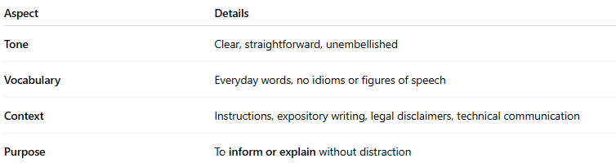
Aspect | Details
Tone | Clear, straightforward, unembellished
Vocabulary | Everyday words, no idioms or figures of speech
Context | Instructions, expository writing, legal disclaimers, technical communication
Purpose | To inform or explain without distraction

🧠 Examples of Plain Diction:
# Source: AI Source: Provided by: [Data Path: Persons Table -> ID Column: 1, Name_En Column: Motasem Essam] -> From: [Chatgpt (GPT-4-turbo)] on [7/30/2025]
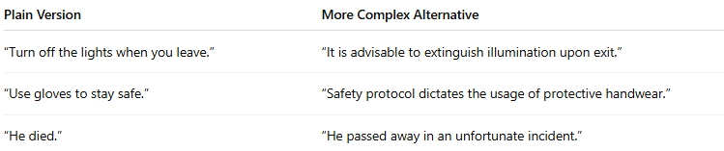
Plain Version | More Complex Alternative
“Turn off the lights when you leave.” | “It is advisable to extinguish illumination upon exit.”
“Use gloves to stay safe.” | “Safety protocol dictates the usage of protective handwear.”
“He died.” | “He passed away in an unfortunate incident.”

✍️ Example Sentences Using Plain Diction:
# Source: AI Source: Provided by: [Data Path: Persons Table -> ID Column: 1, Name_En Column: Motasem Essam] -> From: [Chatgpt (GPT-4-turbo)] on [7/30/2025]
- “The water is hot. Be careful.”
- “Finish your homework before dinner.”
- “This machine stops automatically.”

🆚 Plain Diction vs Other Types:
# Source: AI Source: Provided by: [Data Path: Persons Table -> ID Column: 1, Name_En Column: Motasem Essam] -> From: [Chatgpt (GPT-4-turbo)] on [7/30/2025]
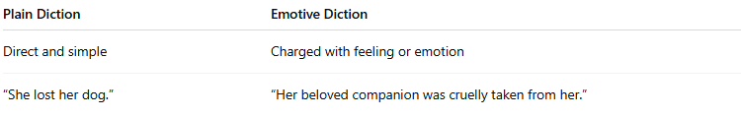
Plain Diction | Emotive Diction
Direct and simple | Charged with feeling or emotion
“She lost her dog.” | “Her beloved companion was cruelly taken from her.”

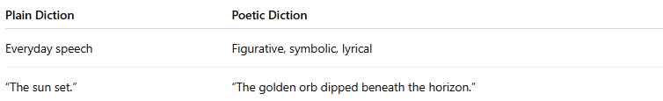
Plain Diction | Poetic Diction
Everyday speech | Figurative, symbolic, lyrical
“The sun set.” | “The golden orb dipped beneath the horizon.”

🧭 Used In:
# Source: AI Source: Provided by: [Data Path: Persons Table -> ID Column: 1, Name_En Column: Motasem Essam] -> From: [Chatgpt (GPT-4-turbo)] on [7/30/2025]
- Manuals and guides
- News reports
- Academic writing (especially in science and tech)
- Business and legal writing
- Everyday conversation

